Original Manuscript ID: Access-20xx-xxxxx
Original Article Title: “ ”

To: IEEE Access Editor
Re: Response to reviewers

Dear Editor,

Thank you for allowing a resubmission of our manuscript, with an opportunity to address the reviewers’ comments.
We are uploading (a) our point-by-point response to the comments (below) (response to reviewers), (b) an updated manuscript with yellow highlighting indicating changes, and (c) a clean updated manuscript without highlights (PDF main document).

Best regards,
<author name> et al.

Reviewer#1, Concern # 1: It would be more helpful to give convergence analysis of the proposed NNLR algorithm. I would also suggest a flow chart included in this paper.
Author response:
Author action: We updated the manuscript by ….

Reviewer#1, Concern # 2: In the conclusions, I would suggest adding a paragraph about the limitations of the proposed methodology. Also, future works need to be discussed in detail.
Author response: Our method is not efficient enough when the number of sample is large, overcoming this limitations will be our future work.
Author action: We updated the manuscript by adding details in V.

Reviewer#1, Concern # 3: Some references should be checked carefully (such as the Refs [10] and [25]-[30]). And some related references are missed, such as:
https://ieeexplore.ieee.org/document/8094872
https://ieeexplore.ieee.org/document/7968372
https://ieeexplore.ieee.org/document/7845582
Author response: We've checked references carefully, and correct the mistakes.
Author action: We updated the manuscript by ….

Reviewer#2, Concern # 1: The authors point out that their algorithm results in flexible bias-variance trade-off in the model fitting, but relevant experiments are not provided to prove this.
Author response: The objective function of low rank regression method LRRR [1] is as follows:

Where 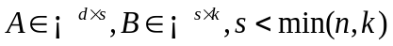, d is the dimension of sample, n is the number of sample, and k is the number of sample category. LRRR uses matrix decomposition to solve the low rank regression problem, and adjust the degree of low rank constraint only through discrete parameter s. The NNLR proposed in this paper uses the Nuclear Norm as a regular term to realize the low rank constraint. The degree of the low rank constraint can be adjusted by adjusting the coefficient before the Nuclear Norm. Therefore, compared with the lRRR method, the NNLR method proposed in this paper can adjust the fitting degree of the model more flexibly and balance the variance and deviation.
Taking the experiment on col101-HOG dataset as an example, the accuracy of LRRR and NNLR methods under different low rank constraint parameters is as follows:
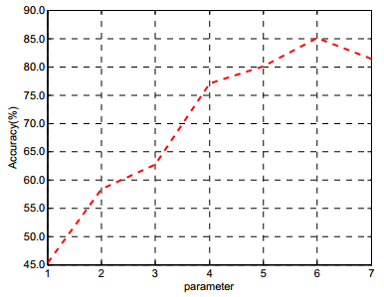
Fig1. Accuracy of LRRR under different low rank constraint parameters
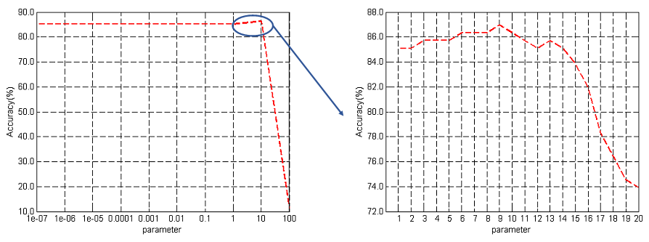
Fig2. Accuracy of NNLR under different low rank constraint parameters
[1] X. Cai, C. Ding, F. Nie, and H. Huang, “On the equivalent of low-rank linear regressions and linear discriminant analysis based regressions,” in ACM SIGKDD International Conference on Knowledge Discovery and Data Mining, 2013, pp. 1124–1132
Author action: We updated the manuscript by adding the experiment and analysis in section IV-D-(4).

Reviewer#2, Concern # 2: The experimental results show that their algorithm does not perform well in the computation time on single-view datasets, and related analysis is absent. Also, some related references are missing, such as "Low-rank regularized tensor discriminant representation for image set classification." and "A Framework of Joint Low-Rank and Sparse Regression for Image Memorability Prediction"
Author response:
Author action: We updated the manuscript by ….

Reviewer#2, Concern # 3: Although the authors said that they have checked the paper and modified all mistakes, there are still many grammatical mistakes in this paper. For example, in the section IV, the phrase ‘sigle-view’ should be ‘single-view’. And in section V, the phrase ‘on some well-known dataset’ should be ‘on some well-known datasets’.
Overall, the innovation of the proposed method is relatively weak, and there are still many grammatical errors.
Author response:
Author action: We updated the manuscript by ….
Note: References suggested by reviewers should only be added if it is relevant to the article and makes it more complete. Excessive cases of recommending non-relevant articles should be reported to ieeeaccesseic@ieee.org

